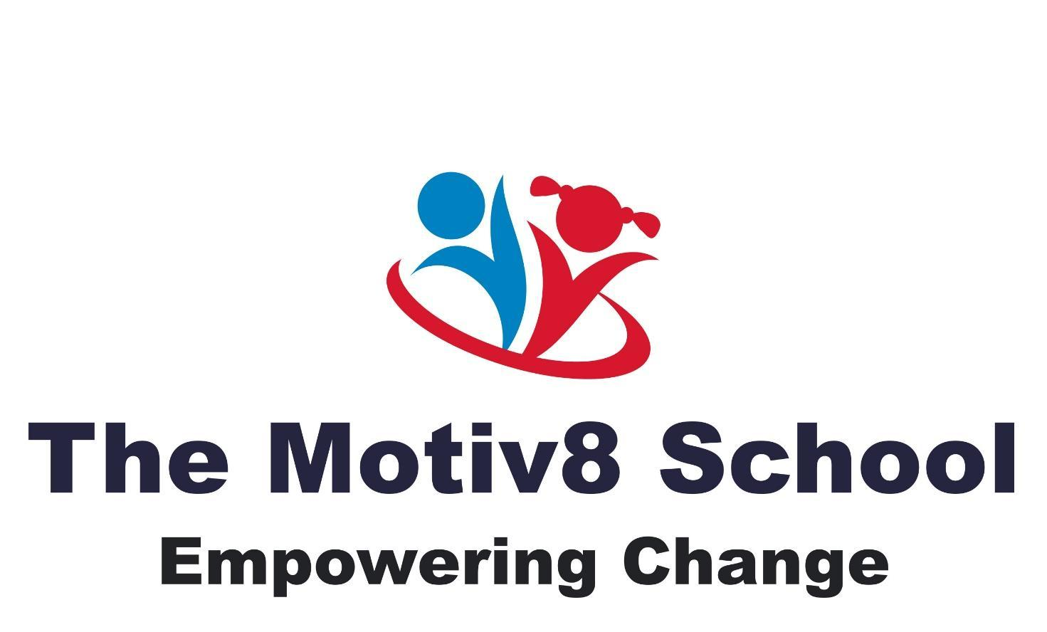

Online Safety – E-Safety Policy

- Policy statement

The Motiv8 School recognises that the use of digital technology and online platforms is an essential part of education, communication, and daily life. However, online activity presents safeguarding risks, particularly for children and young people with special educational needs and disabilities (SEND), who may be more vulnerable to online harm.

Online safety is therefore an integral part of the School’s safeguarding responsibilities. This policy should be read in conjunction with the Safeguarding & Child Protection Policy.

- Scope

This policy applies to:
- all pupils
- all staff
- volunteers
- governors
- contractors
- visitors
It covers use of:
- school IT systems and devices
- personal devices when used on site or for school activities
- online learning platforms
- social media and communication tools

- Key risks

The School recognises online safeguarding risks including:
- cyberbullying
- online grooming and sexual exploitation
- exposure to harmful or extremist content
- sharing of personal information
- misuse of images or videos
- online radicalisation
- scams and financial exploitation

SEND pupils may be particularly vulnerable due to:
- communication difficulties
- social naivety
- literal interpretation of language
- difficulty recognising risk

- Roles and responsibilities

Designated Safeguarding Lead (DSL)

The DSL has overall responsibility for online safety and will:
- respond to online safety concerns
- make referrals where thresholds are met
- liaise with external agencies
- ensure staff training

Staff
All staff must:
- model safe online behaviour
- report online safety concerns immediately to the DSL
- not investigate concerns themselves
- follow the Acceptable Use Policy

Pupils
Pupils are expected to:
- use technology safely and responsibly
- report anything that makes them feel worried or unsafe

Parents and carers
The School works in partnership with parents and carers to promote online safety beyond the school environment.

- Education and prevention

The School:
- teaches online safety as part of the curriculum
- delivers SEND-appropriate, differentiated learning
- revisits key messages regularly
- provides information to parents and carers

- Filtering and monitoring

The School uses appropriate filtering and monitoring systems on its networks and devices to:
- prevent access to harmful content
- identify potential safeguarding concerns
Attempts to bypass filtering systems are treated as a serious matter.

- Reporting concerns

Any online safety concern must be:
- reported immediately to the DSL
- recorded in line with safeguarding procedures
If a child is at immediate risk, emergency services will be contacted.
Concerns involving adults are managed under the Allegations Management Policy.

- Responding to incidents

Responses will be:
- proportionate
- child-centred
- safeguarding-led

The School will:
- support affected pupils
- involve parents where appropriate
- work with external agencies where required

- Acceptable use

All users must follow the School’s Acceptable Use of ICT Policy, which sets out:
- acceptable behaviour
- prohibited activity
- monitoring and sanctions

- Review

This policy will be reviewed annually, or sooner if guidance changes.

Online Safety: Useful Links
Staying safe online is vital for all our learners. Below are helpful links for students, parents, and carers to learn more about how to protect themselves and others when using the internet.

For Young People
- Thinkuknow (by CEOP)
Age-specific online safety advice and games
www.thinkuknow.co.uk
- Childline – Online & Mobile Safety
Support and tips for staying safe online and dealing with cyberbullying
www.childline.org.uk/info-advice/bullying-abuse-safety/online-mobile-safety
- BBC Own It
Interactive site with advice, quizzes, and stories for online wellbeing
www.bbc.com/ownit

For Parents and Carers
- Internet Matters
Comprehensive guides on online safety by age group and topic
www.internetmatters.org
- NSPCC Online Safety Hub
Tools and tips on how to talk to children about online risks
www.nspcc.org.uk/keeping-children-safe/online-safety
- UK Safer Internet Centre – Parents & Carers
Safety tips, social media guides, and reporting tools
www.saferinternet.org.uk/parents
- Common Sense Media
Reviews and guidance on apps, games, and media your child may use
www.commonsensemedia.org

Reporting Harmful or Illegal Content
- CEOP – Report Online Abuse or Exploitation
For reporting inappropriate contact or concerns
www.ceop.police.uk/safety-centre
- Report Harmful Content (UK Safer Internet Centre)
Support for reporting offensive or harmful online material
www.reportharmfulcontent.com
- National Cyber Security Centre – Suspicious Emails and Messages
Report scams and phishing
www.ncsc.gov.uk/section/about-this-website/report-scam-website

