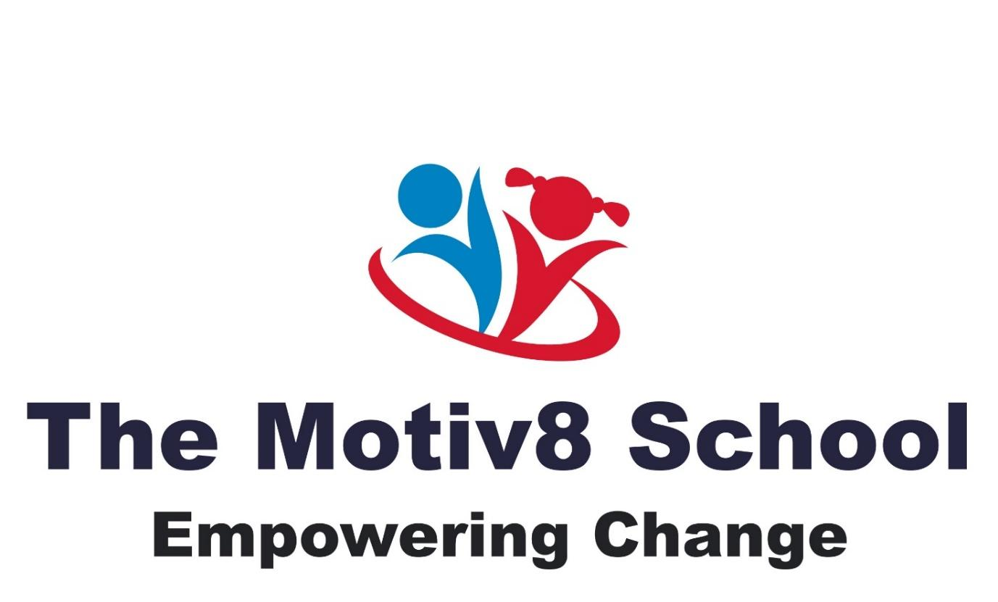

Exclusion Policy

The Motiv8 School - Suspension and Removal from the School Roll Policy (2025)

1. Purpose

The purpose of this policy is to set out how The Motiv8 School manages temporary suspension and permanent removal from the school roll in a way that is lawful, safeguarding-led, and appropriate for an independent SEND school.

This policy should be read alongside the:

- Behaviour Policy
- Safeguarding & Child Protection Policy
- SEND Policy
- Complaints Policy

2. Key principles

The school is committed to inclusion, support, and positive behaviour management. Behaviour is understood as communication, particularly for learners with SEND. Suspension or removal is not used as a punishment, but as a safeguarding and placement-suitability decision. Any decision to remove a learner is taken only as a last resort.

3. Legal context

As an independent school, The Motiv8 School does not follow the maintained-school exclusion framework. Instead, the school operates under:

- its contractual arrangements with parents
- Independent School Standards
- Equality Act 2010
- safeguarding duties

This policy reflects that legal position.

4. Temporary suspension

Temporary suspension may be considered where:

- a learner’s behaviour presents an immediate risk to themselves or others, or
- time is required to assess risk, implement additional support, or review placement suitability.

Safeguards:

- Suspension is time-limited and proportionate
- Parents are informed promptly
- A risk assessment is completed
- SEND needs and reasonable adjustments are considered
- Safeguarding oversight is maintained

Suspension is not used routinely and is reviewed regularly.

5. Permanent removal from the school roll

Permanent removal from the school roll may be considered only where:

- the school can no longer meet the learner’s needs safely, or
- the learner’s behaviour presents a serious and ongoing safeguarding risk, and
- all reasonable support and interventions have been exhausted.

This decision:

- is not disciplinary punishment
- is based on placement suitability and safety
- considers the learner’s EHCP (where applicable)
- considers reasonable adjustments and prior support
- is taken by senior leadership

6. Decision-making process

Before any decision is taken, the school will:

- review behaviour records and risk assessments
- consider safeguarding information
- consider SEND needs and adjustments
- consult internally with senior leaders
- inform parents and allow representations

All decisions are documented.

7. Parental communication

Parents will:

- be informed of decisions in writing
- receive reasons for the decision
- be advised of the right to raise concerns under the Complaints Policy

8. Safeguarding

Where behaviour raises safeguarding concerns, these will be managed in line with the School’s Safeguarding & Child Protection Policy.

9. Review

This policy is reviewed annually or sooner if guidance or circumstances change.

Written September 2024 – Reviewed annually – September 2025
Appendix A

Subject: Temporary Suspension of [Child’s Name]

Dear [Parent/Carer name],

I am writing to inform you that, following an incident on [date], the School has taken the decision to apply a temporary suspension for [child’s name].

This decision has been taken to ensure the safety and wellbeing of [child’s name] and others, and to allow time for the School to complete appropriate risk assessment, review support arrangements, and consider next steps**.

Learner:** [Child’s full name]
Date(s) of suspension:** [start date] to [end date]
Expected return date:** [date]

This temporary suspension is not a disciplinary punishment. It is a short-term measure taken as a last resort to support safeguarding, risk management, and placement suitability, in line with the School’s Behaviour Policy.

During this period, the School will:

* review the incident and relevant information
* consider [child’s name]’s SEND needs and reasonable adjustments
* identify any additional support required for a safe return

We appreciate that this may be a difficult time and are keen to work with you constructively. A meeting will be arranged to discuss [child’s name]’s return to school and the support that will be put in place.

If you have any immediate concerns, please contact me using the details below.

Yours sincerely,
[Name]
[Role]
The Motiv8 School
[Contact details]

Appendix B

Subject: Return to School Following Temporary Suspension – [Child’s Name]

Dear [Parent/Carer name],

I am writing to confirm arrangements following [child’s name]’s recent temporary suspension.

Following review, [child’s name] is expected to return to school on [date]. The School has considered the incident, relevant risk assessments, and [child’s name]’s individual needs, and we will be putting the following support in place to support a safe and positive return:

* [e.g. updated behaviour support strategies]
* [e.g. additional supervision or check-ins]
* [e.g. revised Individual Behaviour Plan / ILP]

We would like to meet with you on [date/time] to discuss these arrangements and ensure we are working together to support [child’s name] effectively.

Please be assured that the School remains committed to inclusion and to meeting [child’s name]’s needs wherever it is safe and appropriate to do so.

If you have any questions prior to [child’s name]’s return, please do not hesitate to contact us.

Kind regards,
[Name]
[Role]
The Motiv8 School
[Contact details]

