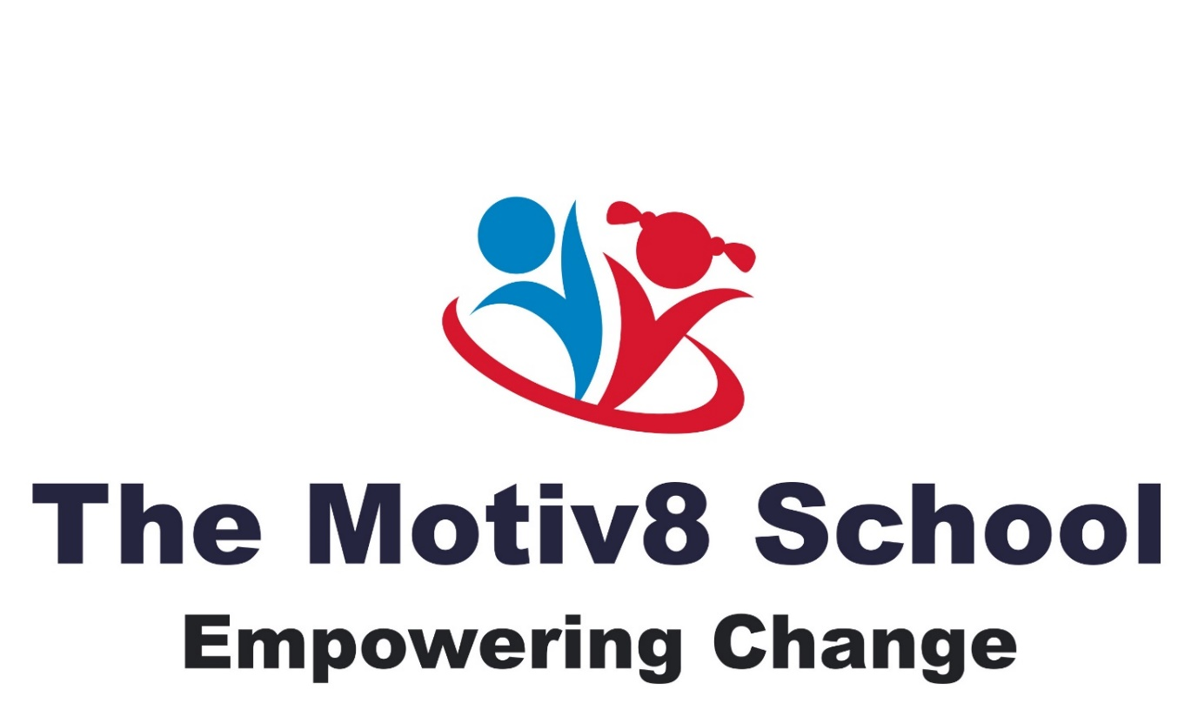

Admission Policy

Written Feb 2025
Updated June 2025
The Motiv8 School

Our Admissions Policy for The Motiv8 School, Special Educational Needs (SEN) school for Key Stage 4 (typically ages 14-16) provides guidelines for how our learners with specific learning needs are accepted into the school. The policy outlines criteria for admission, procedures, and other important details to ensure that the school's resources match the learners' needs.

- Introduction

The Motiv8 School is committed to providing a supportive learning environment for learners with special educational needs aged 14 – 16. Our school aims to offer high-quality education that meets individual needs through personalised teaching and specialised resources. Admission is based on a formal assessment of each child’s needs to ensure that the school can offer appropriate support.

- Aims and Objectives

Our aim to provide education for learners who have struggled in a mainstream setting, or another SEND setting and due to this their special educational needs cannot be met effectively by their current school; or the learner is currently not in education due to their SEND needs, or possibly due to permanent exclusion. To ensure a transparent and fair admissions process that prioritises the well-being and development of the learner, we will work collaboratively with parents/ carers and local authorities, and other agencies to identify suitable and appropriate placements at The Motiv8 School. Our school will provide full time placements for learners in Key Stage 4 or those who are aged 14 – 16. We provide a range of bespoke curriculum needs and we also provide a curriculum for those who can work towards achieving Level 2 in Maths and English in Functional Skills (GCSE Grade 4 equivalent) and who also want to gain an introductory qualification in Welding (City & Guilds) to move into further education/ employment or apprenticeships within engineering.

- Eligibility Criteria

Admissions to The Motiv8 School are open to learners who:
- Have an Education, Health, and Care Plan (EHCP) or equivalent documentation that specifies the need for specialised educational support
- Are aged between 14 and 16 years (Key Stage 4)
- Have specific learning difficulties, emotional and behavioural disabilities (EBD), social, emotional and mental health (SEMH) needs, fixed term or permanent exclusions that impact their ability to learn in a mainstream or other specialist educational setting
- Require more specialised teaching, smaller settings, or other interventions that the school is equipped to provide

The school may admit learners with conditions such as:
- Autism Spectrum Disorder (ASD)
- Attention Deficit Hyperactivity Disorder (ADHD)
- Dyslexia, Dyscalculia, and other specific learning disabilities
- Emotional, social, and mental health needs (SEMH)
- Behavioural difficulties
- Pathological Demand Avoidance

- Application Process

Applications to The Motiv8 School must be made via a formal referral from the Local Authority, current school, an educational psychologist, or another relevant professional. Parents/ carers may also submit an application directly, though it must be supported by the child's EHCP, current school or local authority. Funding must also be agreed by the local authority.

Initial Review: The Motiv8 school will review the EHCP, medical reports, and other supporting documents to assess the learner’s specific needs and whether we can meet those needs.

Consultation with Parents/ Carers: The Motiv8 school will arrange a meeting with the learner’s parents/carers to discuss the learner’s needs, explain the school's offerings, and assess compatibility with the school's resources and environment.

School Visit: Parents/ carers, and the learner will be invited to visit The Motiv8 School to explore the facilities and meet key staff. This visit may include an informal assessment of the learner’s needs by school specialists. This may also include a taster session at the school.

Trial Placement (Optional): In some cases, The Motiv8 school may offer a trial placement (typically 1–2 weeks) to assess how well the learner adjusts to the school environment before making a final decision.

Decision and Notification: A formal decision will be made by the school and relevant professionals, and parents will be notified in writing. If the application is successful, formal arrangements for enrolment will be discussed.

- Admissions for Students without an EHCP

In some cases, learners who do not yet have an EHCP but have been formally assessed by an educational psychologist and other relevant professionals may be considered for admission. The Local Authority must agree to complete an EHCP assessment within a specified timeframe. Any placement without an EHCP will only proceed with written agreement from the Local Authority and appropriate funding arrangements in place.

- Support for Transition

The Motiv8 School will provide transition support for learners moving to The Motiv8 School, especially for those coming from mainstream settings or other special education environments. This includes:
- Meetings with previous school staff
- Transition activities (school visits, familiarisation sessions)
- A personalised induction plan

- Decision Process

If an application is declined, parents/ carers may request a review of the decision and will be informed of alternative options and next steps, including Local Authority processes.

- Monitoring and Review

The Motiv8 school will regularly review its admissions policy to ensure it remains fair and transparent and continues to meet the needs of learners with SEND. This policy is subject to annual review by the governing body.

- Onward Referral:

Learners can be referred onward before their leaving date if The Motiv8 School deem that the placement is no longer suitable to meet their needs. This is a school decision, and the reasons are documented in CPOMS and given to parents/ carers and the local authority. This decision will be made in consultation with parents/carers and the Local Authority, with the learner’s best interests at the centre of the process. In all circumstances we will undertake to refer the learner on to a more appropriate learning environment or back to the Fair Access Panel, the Local Authority, or the referring school.

